The Economics of Vertical Mobility (Summary):

Preface:

This study focuses on intracity air taxis under a base case scenario until 2035

**At a glance:** A brief insight of economics of vertical mobility

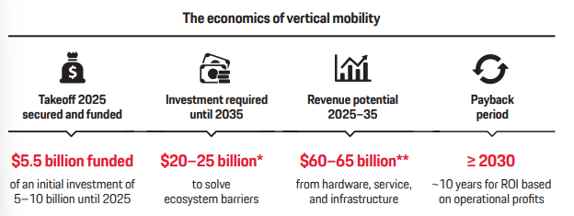

1. Takeoff 2025 secured and funded: Players will have to spend $5–8 billion, without knowing whether and how the public will accept vertical mobility
2. Investment required: The ecosystem is also highly dependent on a minimum investment totaling $20–25 billion to make vertical mobility relevant
3. Revenue potential: we expect a cumulative revenue of $60–65 billion between 2025 and 2035, based on our $21 billion outlook for 2035.

**Economic Outlook for Intracity Air taxis by 2035:**

e how big this market will be, how quickly it will grow, and how great its inherent risks are?

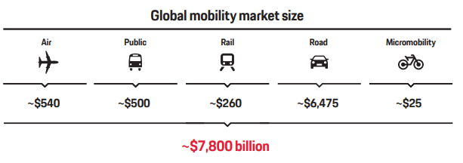

The world’s total mobility market, including hardware and services, is worth approximately $7,800 billion today, with individual road mobility as its largest segment accounting for 80 percent.

By comparison, we forecast that the base case of air taxi services in 2035 will have a market size of $32 billion

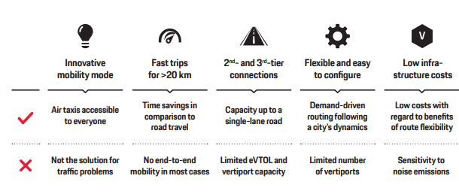

Vertical mobility has the potential to generate benefits for both consumers and cities because eVTOLs are a truly novel mobility mode.

they feature innovative hardware in the field of aviation due to technical breakthroughs in distributed electric propulsion (DEP) systems. Second, they provide an innovative mobility solution to alleviate traffic congestion on the ground. Compared to helicopters, which are currently a luxury offering for some wealthy customers, eVTOLs operate in the premium segment below it and can make urban air travel suitable for and accessible to all of us. Similar to today’s taxis on the ground, they will be a service we can and like to use, but may refrain from doing so every day. While air taxis offer the benefit of time savings, they depend on first- and last-mile accessibility to and from a takeoff or landing site. As vertiports will initially be rare in most cities, this lack of end-to-end mobility can pose a serious constraint.

We expect initial vertiport throughput to be below 100 passengers per hour. Even if Uber Elevate's (acquired by Joby Aviation) vision of megaports with 1,000 takeoffs and landings per hour [4] were to materialize, they could only handle a maximum of 3,000 passengers per hour, based on the assumption of a busy route and of three passengers per air taxi.

Vertical mobility also comes with low infrastructure costs compared to its benefits in flexibility. It is also worth noting that the infrastructure needed for conventional mobility already exists but is often insufficient. Available land in urban areas is scarce, and new infrastructure projects for groundbased mobility therefore carry a high price tag and negative impacts on quality of life.

A market forecast: First, we estimate bottom-up mobility demand across all mobility modes based on the needs of potential users in different cities; Second, we gauge the ecosystem performance across the domains of hardware and technology, service, infrastructure, regulation and law, and social acceptance, underlying assumption that specific infrastructure for takeoff and landing spots is necessary and could be a significant constraint on market development.

Third, we need to analyze the attractiveness of vertical mobility in terms of service accessibility, convenience, its performance and price compared to other modes of transport, and the purchasing decisions customers make. The market will be shaped by the interplay of those three factors. Applying these three basic conditions to the existing and expected mobility mix of a city, we can then estimate the overall eVTOL potential, and in a next step, use this model to extrapolate how it will scale globally.

For passengers eVTOLS: we predict a market potential (base case) of $32 billion in 2035, of which $21 billion come from intracity air taxis. Intracity air taxi service has a cumulative revenue potential of $60–65 billion for hardware, service, and infrastructure in the decade between 2025 and 2035

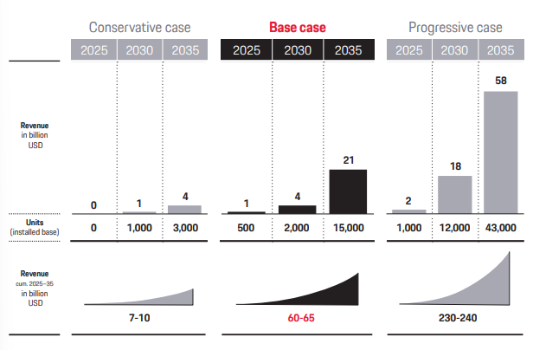

Under the most likely base case, we expect cumulative revenue totaling $60–65 billion between 2025 and 2035, with a potential upside coming from additional private eVTOLs.

The conservative case can still be considered a realistic scenario, as opposed to the progressive case, which we see as a very optimistic black-swan scenario.

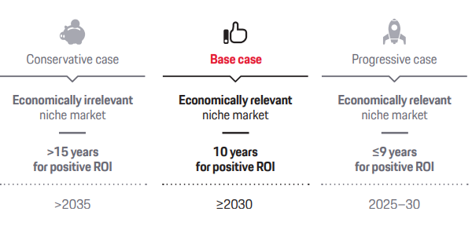

**Investment Need by 2035**

Until 2025, initial investments of at least $5–10 billion are necessary to lay the groundwork that will make intracity air taxis socially relevant. This sum is the minimum, regardless of which case we consider.

On top of that, we expect additional investment demand of at least $15 billion between 2025 and 2035, creating a total investment need in the vertical mobility space of $20–25 billion. The largest share—and with it the greatest risk—will go to hardware manufacturers who will have to invest at least $0.5–1 billion each into their systems. Our model is comprised of five to ten players who will eventually be successful, plus many others who will fail.

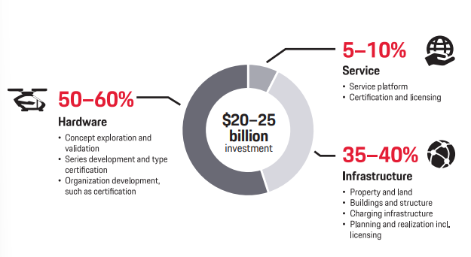

**Vertical Mobility barriers:** The vertical mobility ecosystem rests on five pillars: hardware, service, infrastructure, regulation and law, and social acceptance

Successful hardware hinges on a number of factors, among them the right eVTOL concept, battery technology with sufficient energy and power density, acoustic design that minimizes noise pollution, and a cost structure that makes hardware and operations competitive

Battery: vertical mobility has its own specific demands on how battery technology must be customized, in particular higher energy density and greater power density, which is critical for higher charging rates to enable takeoffs and landings.

Regarding services; air taxi service has to be intermodal and reliable. The speed of the service will be essential for its success. Pooling passengers is one way to reduce the price of air taxi services. Utilizing all available seats, however, requires good demand prediction and a sophisticated dispatch system to react to unforeseen events. This aspect is relevant for reducing operational costs as well.

Regulations concerning hardware, service, and infrastructure as well as social acceptance are other important barriers that will significantly shape the system. All 16 barriers are key for the success of vertical mobility. Due to the large number of barriers, in the following we will only deal very briefly with the topics of battery and energy supply, regulation and law, and social acceptance

**Key requirements:**

Batteries deserve closer attention because they are one of the crucial technical aspects for the evolution of eVTOLs. Once eVTOLs use batteries with an energy density of 400 to 500 Wh/kg, the efficiency and performance of DEP systems will be superior to combustion engines

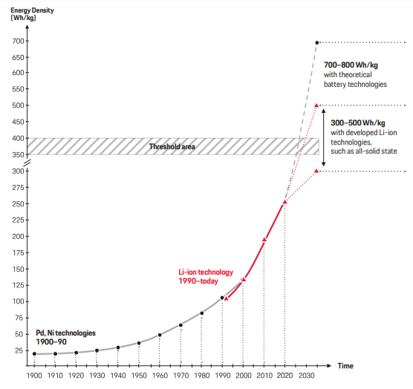

**Regulatory framework:** Regulation is prioritized in aviation to ensure safe air operations since safety is imperative for flying. Today’s dominant authorities are the US Federal Aviation Administration (FAA) and its European counterpart, the European Aviation Safety Agency (EASA). By contrast, vertical mobility will be rolled out as part of regional and local mobility networks, which are subject to regional laws. That is why we expect regulatory authorities to take different approaches and also be beholden to calls for protectionism. At the same time, regulatory authorities, policymakers, and society at large are closely intertwined when it comes to shaping and enforcing those frameworks; the desire for progress.

The regulatory challenge for eVTOLs lies in how emergency situations are handled when flying over densely populated cities. We can assume that eVTOLs will suffer from similar rates of failure as commercial aviation and that those probabilities need to be factored into the development process early on.

**Safety in numbers:** Current practice demands a system reliability of 10-9, which estimates the likelihood of a system failure with catastrophic effect per one-hour mission. Assuming an installed base of 23,000 eVTOLs in 2035 with up to 50 million flight hours per year, a system reliability of 10-9 translates into one eVTOL catastrophic accident with passengers injured or killed occurring every 20 years. Lowering the system reliability to 10-7 would mean five eVTOL incidents of this proportion per year Short of catastrophic failure, incidents during intracity flights can cause damage on the ground and create additional congestion. So even in the 10-9 scenario, smaller incidents have the potential to negatively affect urban traffic.

**Social acceptance as a key requirement:** social acceptance is a fundamental requirement for the vertical mobility market to take off. Customer acceptance is strongly influenced by hardware, service, and infrastructure providers. It is their responsibility to satisfy customers and society at large by ensuring their services are available and reliable and offering clear benefits in terms of time and cost. In a similar vein, social acceptance is tied to the standards set by regulators and lawmakers.

We therefore recommend that lawmakers around the world approve routes only if vertical mobility moves beyond its current status as a luxury niche product and enters the premium niche market. To get there, we need to see attractive and accessible services at a competitive price comparable to today’s taxis on the ground.

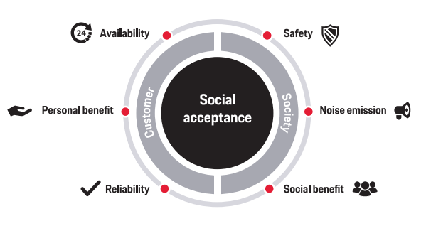

**Social and Economic Relevance:** If vertical mobility is to become economically relevant, it needs to evolve from its status as a luxury offering for the wealthy to an affordable option for wide swaths of the population.

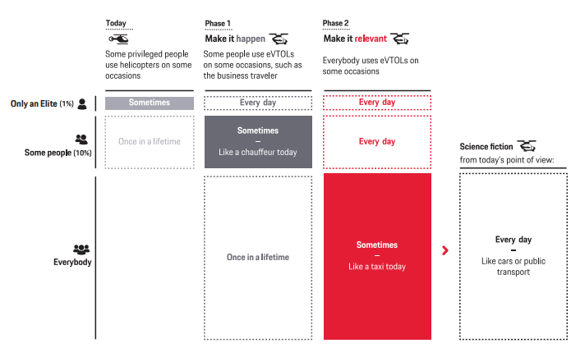

We see vertical mobility playing out in different phases, with Phase 1 dedicated to making it happen and Phase 2 focused on making it relevant. To make it happen we need to get to the point at which some people use eVTOLs on some occasions. Think of business travelers getting from the airport to a convention center much like they do today with a taxi or chauffeur on the ground—still a premium travel method. Making this mode of transport relevant will take it to a whole new level. Everybody will be able to use eVTOLs on some occasions, once vertiports are accessible in their neighborhood and the price for an air taxi is attractive enough, or on par with a taxi today. We can also envision some customers using an eVTOL every day, for instance, if they own a private eVTOL, the cost of which would be comparable to driving a current-day premium or luxury car.

To summarize, the next pic will show the reader what it takes to make the market a real market and, then; to transform it in a bigger market. Either options, will be achievable according to the base case.

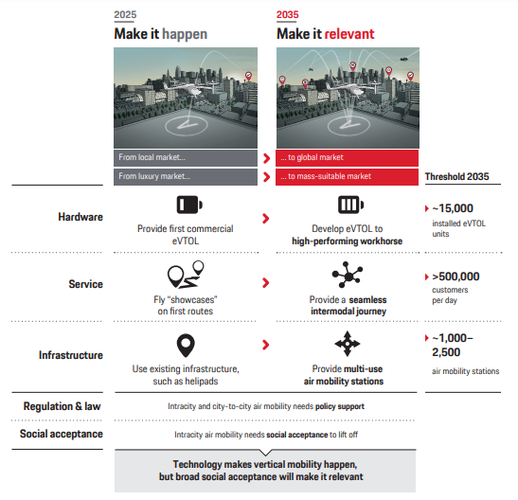

For the base case, more than 30 cities have to establish an intracity air taxi service and the relevant infrastructure by 2035.

**A Guide for Players:** Vertical mobility may be a niche of the overall mobility market, but it is a crowded niche, especially on the hardware side, with more than 200 concepts being developed or at least announced.

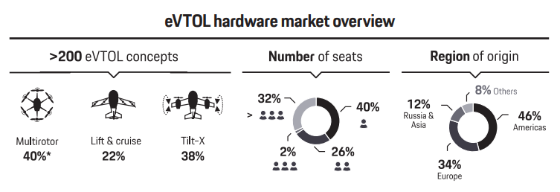

There are currently more than 100 companies intending to bring an eVTOL to market by 2025, but we expect no more than five to ten ventures to become economically successful.

Investors have already poured around $5.5 billion of the first $5–8 billion of required funding into developing passenger eVTOLs. While it is conceivable to make vertical mobility happen with significantly fewer funds devoted to hardware development, less capital would curtail competition among the players. The amount of money invested in eVTOL hardware by 2022 will therefore provide a good indication of where the market is headed.

**The path to make the hardware business economically relevant:** Hardware players need more than good equipment to succeed and make the business economically relevant. Whoever enters this market must be prepared to stay in it for the long run, as at least two eVTOL generations are required to arrive at a fairly silent, highperformance eVTOL workhorse while the market evolves incrementally. We expect no easy shortcuts to get around this timeline.

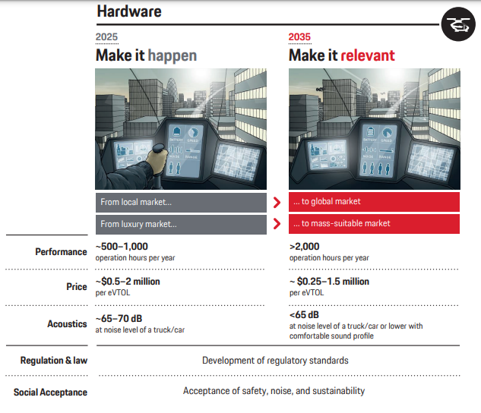

By our estimates, one, two, or a maximum of three eVTOL generations will come to market between 2025 and 2035, depending on the development speed of the underlying technology and the evolution of regulatory standards but also on how investments in the hardware market play out and how team competencies grow.

The first generation of eVTOLs, ready by 2025, will be characterized by limited operation hours of 500 to 1,000 per year due to battery constraints and the relative immaturity of first-generation concepts.

The price of a first-generation eVTOL will range between $500,000 and $2 million, depending on performance, production volume, and the number of seats. We expect its noise level to be between 65 and 70 decibels, comparable to that of a car or truck. Given the increase in road and air traffic, it is critical to reduce noise emanating from both an eVTOL and infrastructure on the ground. Selecting the right locations can make a big difference.

If the market volume for eVTOLs does not grow beyond this initial stage, however, costs will not decrease, leading to a lower number of customers and less social acceptance. Under this scenario, a first-generation eVTOL would be just an electric version of a helicopter and the overall market would merely develop into a very small, economically and socially irrelevant niche.

Several things need to happen to eventually make the market for vertical mobility relevant. First and foremost, eVTOLs have to evolve into high-performance workhorses. Follow-on generations of air taxis will have an increased performance of more than 2,000 hours per year, enabled by increased efficiency, which in turn is driven by battery improvements and more mature systems. By then, we expect batteries to have an energy density of 350 to 400 Wh/kg. The cost per eVTOL will decrease to between $250,000 and $1.5 million as production volumes go up and costs adjust to the improved performance and available number of seats. Noise levels, we believe, will drop below 65 decibels, offering a more comfortable sound profile. Further acoustic improvements are key to raising social acceptance in many regions and will also allow eVTOLs to stretch their operating hours without being perceived as a nuisance.

**Possible strategies to become a relevant hardware player:** players need to demonstrate a solid business case for the first generation of their equipment to ensure a positive ROI and be able to quickly invest in the next generation of eVTOLs. They can pursue several strategies to reach relevant hardware volume. Serving a global market is one very important option, as is focusing on combining multiple use cases (e.g., private air taxis, commercial air taxis, or the fairly small goods market) into one product or product platform.

Players who focus on a regional or local business will have little chance to become economically relevant, given the limited size of the market and the volume involved. That is why addressing and serving a global market is an equally crucial and complex task. One alternative consists of relying on subsidies to gain a competitive advantage in regional markets, another on keeping prices high, yet both would limit the size of the addressable market. We believe it would be similarly be ill-advised to lower the certification requirements at the expense of operational safety. Market entrants can pursue various possible strategies to succeed. One option is to develop an eVTOL for commercial applications. Reaching a high sales volume could be achieved by diversifying into other applications such as private use, which allows an even earlier start due to lower regulatory hurdles. This approach is also a good way to accumulate valuable flight hours and gain experience

A second strategy involves a company’s development of an eVTOL exclusively for private use. The private market, however, needs a base layer of infrastructure to function, which poses higher risks with fewer viable business cases. There is a chance to make this happen with investments of just $250,000 to $500,000 for eVTOL development. This approach carries the risk, however, that a direct upgrade for commercial applications will not be possible. Otherwise, we expect investment needs to run at least in the aforementioned range of $500,000 to $1 billion per system.} Should a company want to play it safe, it can choose the third strategy and be a follower. This path would eventually hurt overall market development, however, since daring pioneers are essential to accumulating enough critical know-how and making progress. The entire vertical mobility market would suffer from this lack of experience and expertise. Furthermore, late entry may turn out to be too late if the market has already been divided up among the other players.

A fourth possible path to commercial success consists of a company focusing on a particular niche by becoming a supplier of critical components for eVTOLs, such as batteries, structural components, systems for autonomous flight, and DEP.

**11 identified players:**

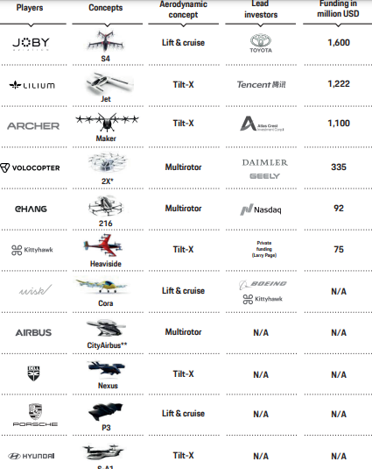

**Service Player:** In contrast to the eVTOL hardware business discussed in the preceding , we expect that the eVTOL service business will require much lower capital expenditure investments by 2035, totaling at least $1 billion.

Running a vertical mobility service is a local play, with each urban service depending on the individual needs and particular mobility pain points of a city. Providing the right service on the right routes is key and determined by the interplay of the service itself with the available infrastructure. Service providers must therefore study and adjust for the regional differences and local specifics of their target market. They include geographical and meteorological conditions, population density, the current mobility mix and mobility behavior of its residents as well as existing infrastructure and economic indicators such as the city’s GDP and income distribution.

At the regional level in 2035, we predict a regional market revenue split of 30 percent for the Americas (North and South), 45 percent for the Asia-Pacific region, and 25 percent for Europe and the rest of the world

**Success factors for service providers:** We identify three main phases, in which, the services have to get a “must have”.

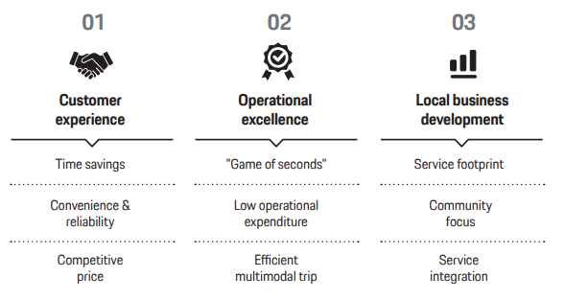

**The path to making the service business economically relevant** Service providers will need cities that support them with the approval of test routes and ideally have access to existing infrastructure to accommodate their routes and takeoff and landing slots. We consider the current air traffic management (ATM) system sufficient to get the first air taxi services started and therefore do not expect it to pose a missioncritical constraint.

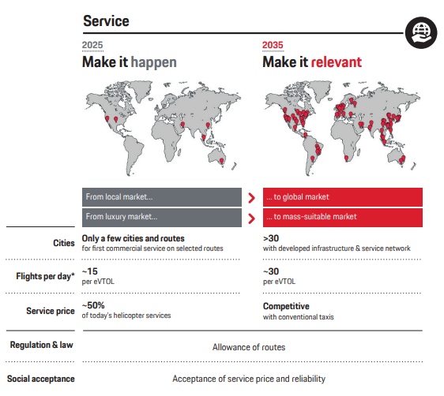

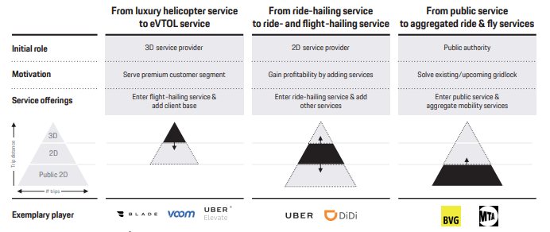

**Infrastructure Player:** Assuming that by 2035 a minimum of 30 cities launch an air taxi service with a relevant number of flights and routes, we expect minimum investment needs totaling $7 billion. This sum would cover the costs required to enable vertiport operations for eVTOL air taxi service in more than 30 cities with an expansive vertical mobility infrastructure, or more than 200 cities with a lower build-out rate. In the conservative case, only a few cities will have air taxi services in operation, while the progressive case envisions more than twice as many cities. The number of slots is the all-important bottleneck for the infrastructure build-out, as those slots ultimately determine the service capacity in a city.

Investors in eVTOL infrastructure should plan an ROI horizon of 15-plus years, with the actual time frame to recoup their investment determined by the number of vertiports and the specific expansion plans. Investment needs will rise proportional to the maximum number of turnarounds per hour. Our model takes into account three different configurations for vertiport infrastructure: vertistop as well as small and large vertiports.

Infrastructure is above all a local play that consists of building a unique vertiport network for each city. The given urban infrastructure of houses, skyscrapers, parking garages and the like determines how vertiport infrastructure should be designed, such as meeting safety and passenger security requirements. Building and zoning codes and permit processes vary by city and are also influenced by community acceptance. At the same time, there are regional standards based on product specifications for charging plugs, charging currents, ground handling technologies, and space requirements.

The passenger transportation capacity of an air taxi service is limited by the number of vertiports but also by their type and size. We distinguish between three different types of vertiports: vertistop, small vertiport, and large vertiport. For a greenfield approach, some players see megaports with a thousand takeoffs and landings per hour (at a rate of 1.8 seconds per takeoff or landing) as a potential fourth configuration, which Uber also envisioned in 2018. We do not expect, however, that such large facilities will become a relevant reality by 2035.

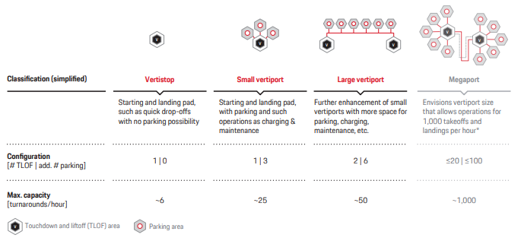

**Success factors for infrastructure providers**

**The path to making the infrastructure business economically relevant** Our market model can simulate infrastructure development in three stages per city, from an initial and an extended buildout to a full-blown expansion phase. We expect that existing infrastructure, such as helipads, will be adjusted to meet eVTOL requirements by, for instance, adding charging points to allow first tests by somebody on some occasions. Concurrently, companies in the space will accumulate essential know-how about the infrastructure components essential for vertical mobility. This phase will define common infrastructure standards based on product standards, as well as the standards concerning certification under applicable aviation laws and building codes. At the outset, the first vertiport networks will only exist in a few cities. The first routes between hubs such as airports and train stations will be serviced, partially replacing existing helicopter routes. Existing infrastructure such as parking garages will be adapted to eVTOL needs to expand the vertiport network and alter its configuration to accommodate more turnarounds per hour.

In 2025 we expect fewer than 50 vertiports worldwide, with about 1,500 takeoffs per hour for the first routes. This total is limited by the number of possible turnarounds per vertiport per hour.

For an economically relevant scenario in 2035, we forecast a need for 1,000 to 2,500 air mobility stations—relevant vertiports that are fully integrated into the existing city mobility. They could be in the form of 1,000 large or 2,500 midsized vertiports in more than 30 cities with developed infrastructure, or alternatively spread out among more than 200 cities with fewer routes if the build-out were to occur at a smaller scale. Existing heliports already have a certain basic infrastructure for commercial operations and therefore lend themselves to this type of retrofit. Looking at global statistics, only the USA with its more than 5,000 existing heliports offers a sufficient number of takeoff and landing sites that could be used for air taxi service, albeit without a charging infrastructure. The growing pains of electric mobility on the ground are a good reminder of how crucial and time-sensitive the build-out of charging stations is. Next is Korea as a distant second with more than 400 heliports; all other countries have significantly fewer than 100 heliports. **we forecast a need for more than 65,000 takeoffs per hour by 2035 for the $21 billion intracity vertical mobility market alone.**

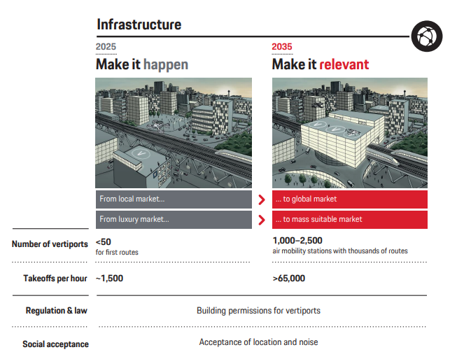

**Possible strategies to become a relevant infrastructure player**

Infrastructure providers can start with the existing 3D infrastructure, such as helipads. This approach lets them gain know-how in operating such infrastructure from ground handling to charging. From there they can develop a vertiport network that makes a difference in urban transport, as long as they always focus on a clear business case.

A second approach consists of building an open system—that is, with no specific match of hardware, service, and infrastructure— creating new meeting points or micro-cities. While they offer the benefit of being flexible, they also risk suffering from a lack of infrastructure standards. This approach focuses on finding attractive vertiport locations by either creating new traffic hubs or integrating vertical mobility into those already present. A company can follow a brownfield approach and adapt existent infrastructure to eVTOL requirements, integrating vertical mobility into parking garages, hotels, and malls.

A third exemplary strategy is characterized by a public-private partnership that integrates vertiports into existing traffic hubs. Companies would have to seek out established nodes like airports and subway or train stations and augment them with vertical mobility infrastructure. This approach must be driven by network neutrality, offering every service provider access to these facilities.

Generally speaking, players like real estate developers, owners of attractive properties, and airport and parking space operators could be successful in this market. Developers are particularly focused on the construction and financing of vertiports. Uber Elevate (acquired by Joby Aviation), for instance, has commissioned real estate developer Hillwood for the city of Dallas and Related Companies for Los Angeles and Santa Barbara to develop vertiports. Airport operators are mainly specialized in airport operations, but they can also be co-owners of the respective vertiports. Skyports, for example, is developing and intends to operate one of the first vertiports in cooperation with the city of Singapore and Volocopter. FraPort, which operates the Frankfurt airport, also wants to integrate eVTOL operations at its existing airport in Germany. Another potential player is Signature Flight Services, which is already running airport operations for Uber Elevate's helicopter service in New York. The challenge for airport operators lies in the faster speed of the eVTOL business. A 15-minute delay is almost a given for an airline customer but will be a showstopper for air taxi passengers. Successful operators also need to focus more on the customer journey and less on ringing up concession sales between the security checkpoint and the gate. This shift could also have a positive impact on airport processes for airline customers, motivating the former to optimize their processes.